MEMORANDUM
TO: All JWF Staff and Trustees

FROM: Katharine Kovan, Consultant

DATE: December, 2013

RE: Results of Trustee Satisfaction Survey

Introduction; Survey Project Goals

The Jewish Women’s Foundation of Metropolitan Detroit (JWF) has new professional leadership. To facilitate the leadership transition, the JWF created a survey with the objective of learning more about our Trustee’s experiences and their satisfaction with a broad range of participation options. The survey had two goals:
- To offer current and alumnae Trustees the opportunity to express feelings and opinions about the JWF Trustee experience, and
- To provide the JWF lay and professional leadership with feedback that will help it evaluate past JWF operations and accomplishments with an eye toward future improvement.

Survey Questions and Responses

JWF current Trustees and Alumnae were asked various questions about their experiences with the JWF.

The first questions were about how they learned about the JWF and why they made commitments to join the JWF.

Most often, Trustees first heard about the JWF by word of mouth. However, many women also noted hearing about the JWF through their prior involvement with the Jewish Federation of Metropolitan Detroit.

Respondents spoke freely regarding what influenced their decision to become a JWF Trustee. Several notable responses include:
- “I felt that is was a hands on way to see where my money was going.”
- “The chance to make a difference in women and girls lives”
- “Felt it would be empowering to help determine how money is allocated and be involved in the process.”
- “Desire to be part of a strong woman's decision making process.”

The largest concentration of current Trustee responses, 33.93%, came from Lifetime members.
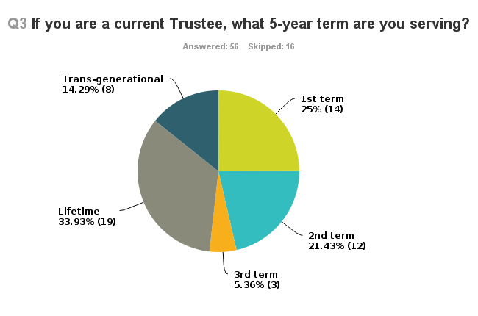
As previously noted, JWF Alumnae were also asked to complete this survey. Their input was particularly helpful, offering insight about why some women choose to discontinue their memberships after their initial commitments are fulfilled.
- One respondent noted the meeting hours as being inconvenient for a businesswoman.
- Several respondents cited the financial commitment as their reason for not renewing.

Continued on next page

Most respondents (33.82%) are moderately involved, either regularly (39.71%) or intermittently (36.76%) attending board meetings.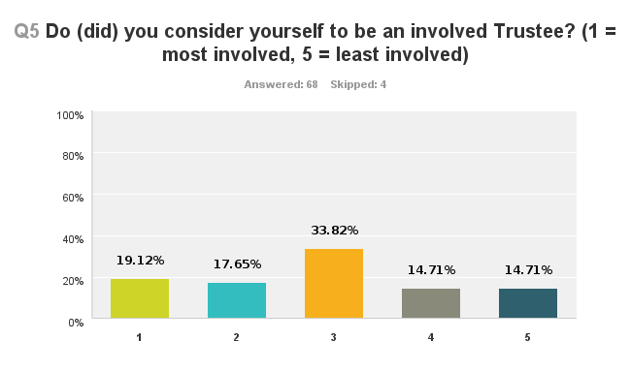

The majority of women (62.12%) have taken their commitment to the JWF even further by serving on a Standing Committee. Respondents described their experienced on a Standing Committees as educational, empowering, and very positive.
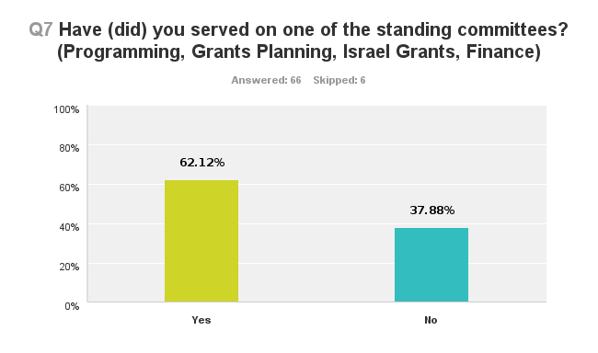

An overwhelming majority (87.88%) of women who responded had attended programs and educational forums and reported very positive experiences. The majority of those rated programs at “1”, the highest rating, describing them as educational and enlightening.
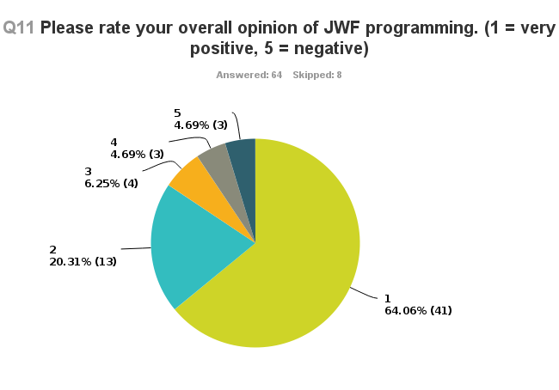
Of the Trustees who responded to the survey, 85.48% participate regularly and actively in the grants process. The majority of respondents were extremely satisfied with all components of process (grants packets and materials, grants determination meetings, site visits, annual meetings). Trustees felt included in the process, and noted that grants planning meetings are interesting, organized, inclusive, and friendly.
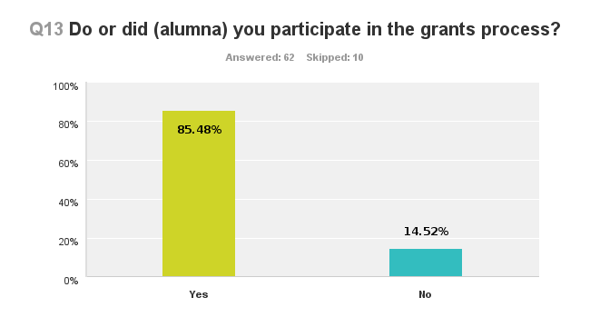
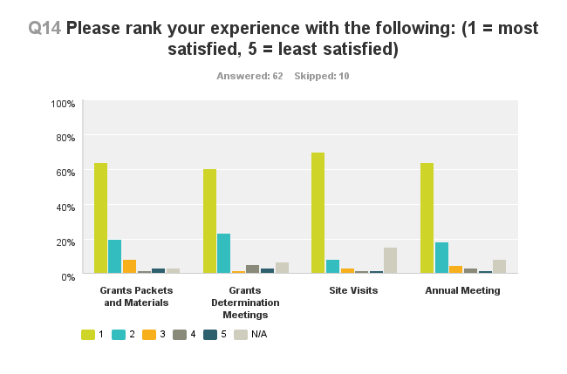

The free response comments at the end of the survey provided the most room for JWF growth and evaluation.

Because the JWF is always working to improve the Trustee experience, I reviewed comments for those that would help in this process. Several helpful comments were critiques:
- The “inflexibility of meeting hours”
- The “repetition in notices and papers…[as it can be] expensive [and] redundant”
- The idea that JWF Trustees are “not free to speak [their] minds….[to avoid] a war of “words”

Negative comments, however, were very sparse. Positive comments were plentiful and revealed a high level of satisfaction with the Trustee experience. Several notable responses include:
- The “JWF enriches my life in the process of enriching other lives. I look forward to every meeting or event and never am disappointed.”
- “I'm so proud to be amongst the dynamic women who maintain the integrity of our wonderful organization!”
- “JWF has had wonderful leadership by many very competent women I was proud to have belonged to such a high achieving organization. They have set the bar high for future leadership.”
- “I have thoroughly enjoyed my experiences as a trustee. The JWF has lived up to its mission and purpose and I am proud to have been able to contribute to the success of this fine organization. Because of my involvement, I've learned so much about grant-making and the ability of women to make a difference.”

Conclusions

This survey offered important feedback from both current JWF Trustees and JWF Alumnae. Of the 72 women who responded to the survey, 78% of the respondents were current JWF Trustees, and the other 22% was comprised of JWF Alumnae. The largest concentration of current Trustee responses, 33.93%, came from Lifetime members, which seems to echo their lifetime pledge of support to the JWF.

Survey results showed a significantly high level of Trustee satisfaction and involvement. JWF Trustees expressed passion for the work of the JWF through their overwhelmingly positive feedback.

Specifically, respondents noted their satisfaction with JWF programs and educational forums as well as the grants process. The 85% of respondents who granted each of these facets of the organization a superior rating demonstrates that JWF Trustees and Alumnae are (were) very involved in the organization and passionate about its mission of expanding opportunities and enriching the lives of Jewish women and girls.

In addition, JWF Trustees indicated that they feel empowered by the work that they do. This translates well into the number of Trustees who have served on a standing committee. A majority of Trustees’ responses exhibit a deep level of commitment. Their comments indicate that their experiences in leadership positions are educational, empowering, and very positive.

The survey results indicate that the JWF’s ongoing efforts to improve and grow have traction. Constructive criticism is equally important as the praise and offers the JWF some challenges that will help them to improve their operations.

My overall conclusion is that the JWF does outstanding work. It maintains a strong focus on its mission and goals with the support and involvement of its Trustees and Alumnae.

